South Australia
The Electricity Trust of South Australia (Torrens Island Power Station) Act 1962
An Act to vest in the Electricity Trust of South Australia portion of Torrens Island and to authorise the Trust to construct certain embankments, barrages, bridges and other works, and for other purposes.

Contents
1 Short title
2 Resumption of certain reserves
3 Vesting of certain land in Electricity Trust of S.A.
4 Construction of power station
5 Power to construct bridges etc
6 Non-liability of Trust for damages
7 Saving
Schedule 1
Schedule 2
Schedule 3
Schedule 4
Legislative history

The Parliament of South Australia enacts as follows:
1—Short title
This Act may be cited as The Electricity Trust of South Australia (Torrens Island Power Station) Act 1962.
2—Resumption of certain reserves
(1) Notwithstanding the provisions of section 64 of the Harbors Act 1936 the reserves defined in Schedule 1 to this Act and the land defined in Schedule 2 to this Act are hereby withdrawn from the South Australian Harbors Board.
(2) Notwithstanding anything in the Crown Lands Act 1929 contained, the reserve defined in Schedule 3 to this Act is hereby resumed.
3—Vesting of certain land in Electricity Trust of S.A.
The land shown in the plan in Schedule 4 to this Act and therein hatched in black being that portion of Torrens Island numbered section 453 Hundred of Port Adelaide and extending to low water mark is by force of this Act vested in The Electricity Trust of South Australia for an estate in fee simple.
4—Construction of power station
The Electricity Trust of South Australia may on the land vested in it by section 3 of this Act construct and operate a power station or power stations together with any other structures, equipments, buildings, offices, ancillary works and facilities it may deem necessary for the purposes of its undertaking.
5—Power to construct bridges etc
Notwithstanding any other Act or law The Electricity Trust of South Australia may for the purposes of any power station to be constructed or which has been constructed by it on the land vested in it by section 3 of this Act—
(a) construct a temporary barrage across Angas Inlet in a position approximately as shown on the plan in Schedule 4 and therein marked "A" from Torrens Island to Garden Island, thereby preventing access by water between Angas Inlet and North Arm; and
(b) construct a temporary bridge across the North Arm in a position approximately as shown on the said plan and therein marked "B" from Torrens Island to the mainland on the southern side of the North Arm at low level and without any lifting or opening device; and
(c) construct a permanent bridge or a permanent embankment across Angus Inlet in a position approximately as shown on the plan and therein marked "C" from Torrens Island to Garden Island and if a bridge without any lifting or opening device and if an embankment thereby permanently and completely preventing access by water between Angas Inlet and North Arm; and
(d) construct a permanent bridge in a position approximately as shown on the plan and therein marked "D" from Garden Island across the North Arm to the mainland at low level and without any lifting or opening device.
6—Non-liability of Trust for damages
The Electricity Trust of South Australia shall not be liable for any costs, charges, compensation or damages whatsoever to any person whatsoever arising from or out of the said constructions as provided by this Act whether by reason of hindering or preventing navigation between Angas Inlet and North Arm or by reason of diversion of waters or otherwise howsoever.
7—Saving
Nothing in this Act shall take away or restrict any other rights or powers of The Electricity Trust of South Australia.

Schedule 1
1 Reserve, section 391, hundred of Port Adelaide, (formerly Reserve No. 8 adjoining section 867), the proclamation of which was published in the Government Gazette dated 24 April, 1879.
2 Reserve, section 390, hundred of Port Adelaide, (formerly Reserve No. 9 adjoining section 872) the proclamation of which was published in the Government Gazette dated 24 April, 1879.
3 Reserve, No. 10, south-west of and adjoining section 875, hundred of Port Adelaide, the proclamation of which was published in the Government Gazette dated 24 April, 1879.

Schedule 2
That portion of the hundred of Port Adelaide, comprising the portion of Garden Island west of the eastern boundary of preliminary section 2020 and its production northerly to Angas Inlet, and southerly to the North Arm, being portion of the land acquired under the Harbors Act of 1913, as published in the Government Gazette dated 11 April, 1918.

Schedule 3
The remaining portion of reserve for quarantine ground for stock, being portion of section 2016, hundred of Port Adelaide, the proclamation of which was published in the Government Gazette of the 5th March, 1891.

Schedule 4
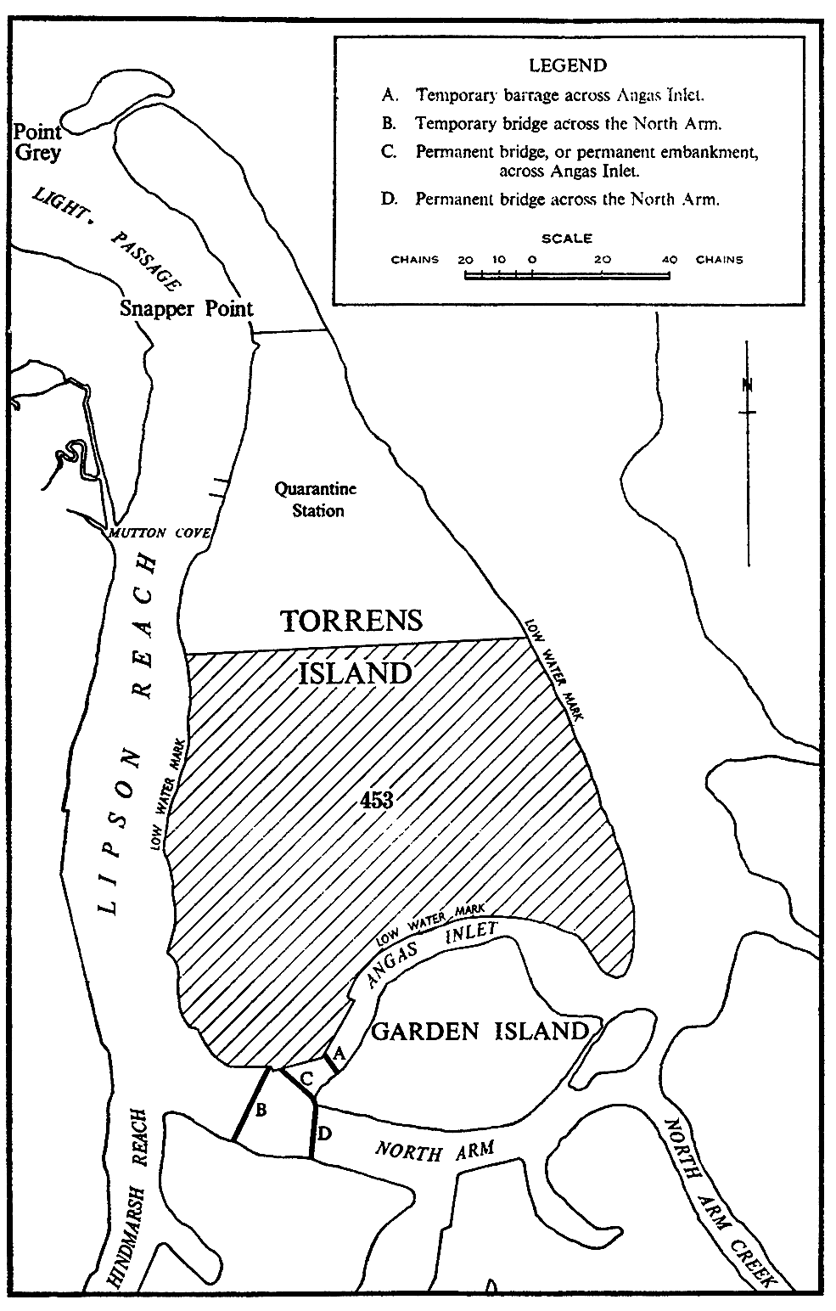

Legislative history
Notes
• For further information relating to the Act and subordinate legislation made under the Act see the Index of South Australian Statutes or www.legislation.sa.gov.au.
Principal Act
Year | No | Title | Assent | Commencement
1962 | 31 | The Electricity Trust of South Australia (Torrens Island Power Station) Act 1962 | 1.11.1962 | 1.11.1962

